* **Setup to run scripts with selenium grid in docker**

1. Install docker in your local machine from the below url [**https://www.docker.com/products/docker-desktop**](https://www.docker.com/products/docker-desktop)
2. Below given file is to configure hub and nodes.



1. Open Command prompt and navigate to the same docker-compose file.
2. Run **docker-compose up –d** command to start the hub and nodes.
3. Once the sever is up run the scripts from the eclipse with the help of the testNG file.
4. To stop the server run **docker-compose down** command

**Content in docker-compose.yml file**

**Version 3:** version of the compose file format.

**Services:** Defines all the services you want to deploy.

We are using three services 1 for selenium hub and two for nodes chrome and Firefox.

**Image:** defines docker image e.g. selenium/hub, selenium/node-chrome, selenium/node-firefox.

**Ports:** Ports mentioned in docker-compose.yml will be shared among different services started by the docker-compose.

**Environment:** It is used to set environment variables.

**MAX_SESSION:** This means how many browsers can run in parallel at a time in remote system.

**MAX_INSTANCES:** This means how many instances of the same browser can run over the Remote System.

**HUB_PORT_4444_TCP_ADDR:** This represents the address of the hub.

**HUB_PORT_4444_TCP_PORT:** This represents the port number which we are using for hub e.g. 4444.

* **To See the execution**

1. Replace the image files for selenium/node-chrome and selenium/node-firefox with selenium/node-chrome-debug and selenium/node-firefox-debug in docker-compose.ym file as below attached file.



1. Download VNC Viewer from below url.

<https://www.realvnc.com/en/connect/download/viewer/>

1. After starting server and nodes open VNC viewer.
2. Enter hub address followed by port number in address bar of VNC viewer as below screenshot.

For local machine give 127.0.0.1 followed by port number.

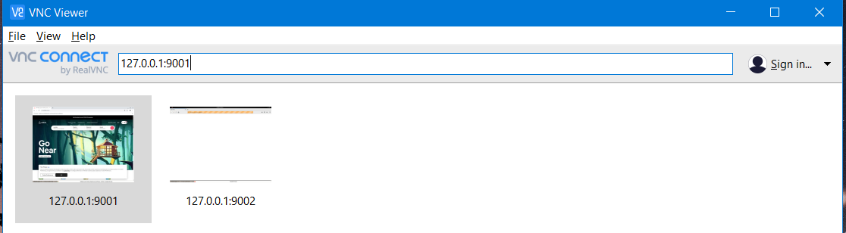

1. Enter password as **secret** in VNC viewer and click on continue.

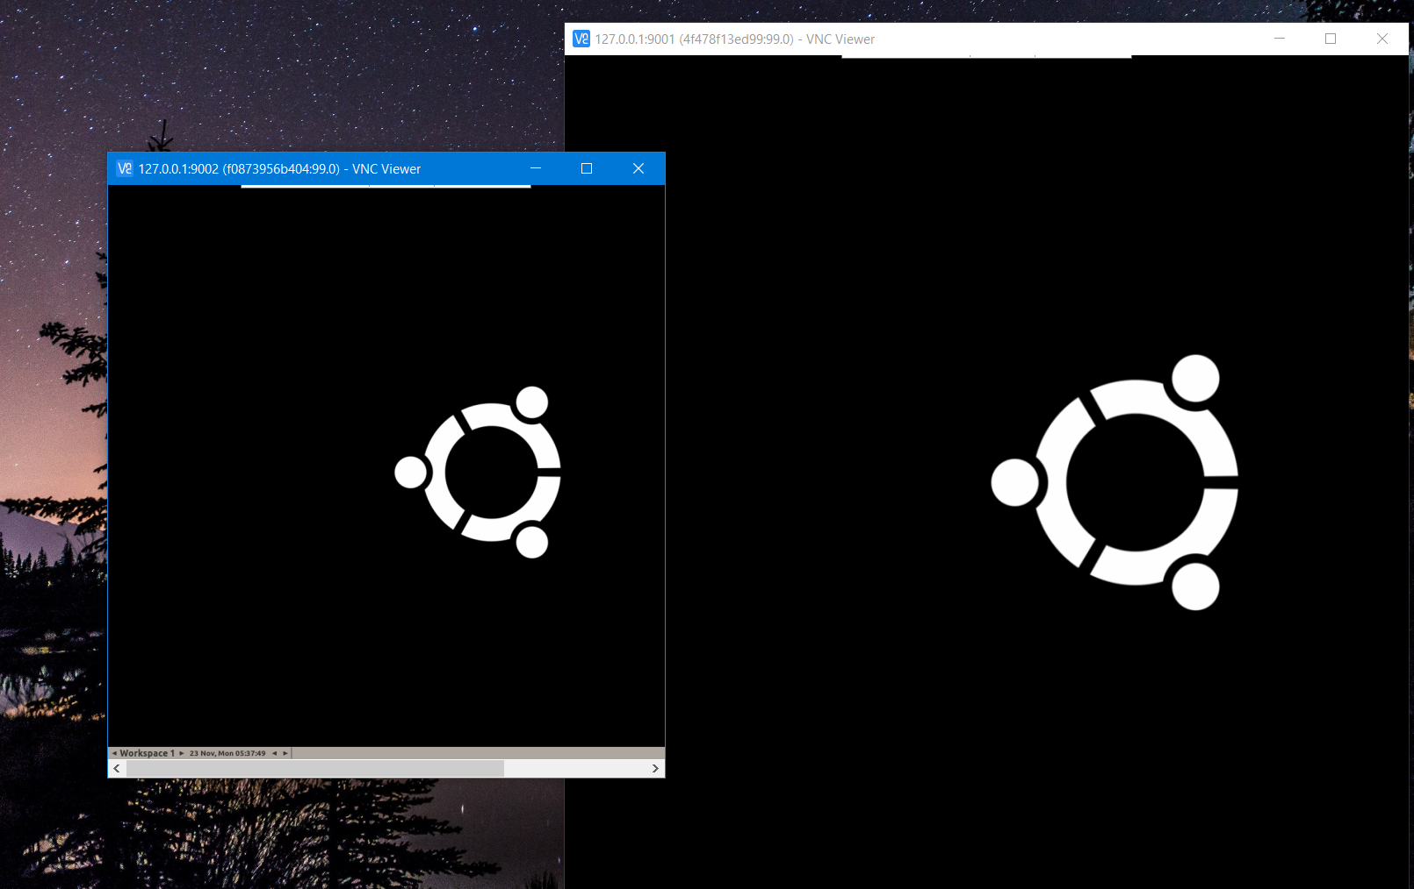

1. When you start the execution it’ll show in VNC viewer.

